**Design Document: Cloud-based Data Integration Solution**

**1. Introduction**

This design document outlines a suitable solution for integrating user data from multiple systems of Company A into a single system hosted on Company B's cloud-based environment. The data from Company A is inconsistent and might contain duplicate records due to acquisitions and mergers. The two data sources include a REST-based API and a file placed into a known location for processing. The solution aims to address data consistency, resiliency to network changes, error handling, and efficient use of cloud resources.

**2. Solution Overview**

The proposed solution involves a cloud-based data integration platform that performs data extraction, transformation, and loading (ETL) operations to consolidate user data from Company A's systems into Company B's system. The key components of the solution are as follows:

**2.1. Cloud Platform**

The solution will be hosted on a modern cloud platform (e.g., AWS, Azure, Google Cloud) to take advantage of its scalability, reliability, and managed services. The solution will be built in ASP .NET that will be able to be deployed and executed in any of the cloud service mentioned above.

**2.2. Implementation**

The solution will take advantage of and be implemented on SSIS in ASP .NET. For easy demonstration purpose, there will be no SQL server involved in this project. All data manipulation will be carried out through text files stored locally.

**2.2. Data Structure**

Upon review, JSONPlaceholder’s user data structure is as follows:

Class Geo{

Decimal lat

Decimal lng

}

Class Address {

String street

String suite

String city

String zipcode

Geo geo

}

Class Company{

String name

String catchphrase

String bs

}

Class user{

Int id

String name

String username

String email

Address address

String phone

String website

Company company

}

A custom generated csv data is named users.csv and located at the root directory. The data is only consist of simple data structure

String First_name

String Last_name

String email

String phone

String company_name

Int id

String phone

The two sets of data have quite different data fields and we aim to integrate two sets of data into one.

**2.3. Data Consistency**

As the sets of data are quite different. To simplify the demonstration, only the phone numbers are used to be the only factor to identify the user, although names and email address could also be considered to identify a person.

Within this project, when the same phone number appear in both sets of data, of which the row will be appended to a csv file for manual processing. csv_duplicates.csv and json_duplicates.csv are the output files.

The common fields of these two data sets are decided as follows:

String FirstName

String LastName

String Email

String Phone

String CompanyName

Remaining data will be abandoned.

**2.4. Data Integration Layer**

The data integration layer will be responsible for orchestrating the data integration process. It will include the following components:

2.3.1. Data Extraction and Processing

* For the REST-based API source, HttpClient will be used called from a script component to consume JSONPlaceholder’s user API.
* As names in JSONPlaceholder do not separate first and last, they will be processed into First_name and Last_name before the data is staged to the SSIS data flow.
* As there are extensions numbers after some phone entries in JSONPlaceholder. The extension number will be trimmed for comparison. Also hyphen and parentheses will be removed to form a new column phone_main to enable direct comparison..

compare directly between two data sets.

* For the file source, native SSIS Flat File source will be used to read the CSV file.
* Finally both processed data sets will be saved as CSV files for the next stage process.

2.3.2. Data Merging and Posting through RESTful API

* Data merging is isolated from the process above because a cache file will need to be created first before SSIS starts a lookup action. Therefore all data will be saved as csv files (csv_userdata_before_merge, json_userdata_before_merge.csv) for the next merge process.
* After a lookup is performed, rows without duplicated phone numbers will be merged into a table (FirstName, LastName, Email, Phone, CompanyName).
* Once all data is gathered, SSIS will fire a script component to post a list<user> json string to the Company B API (<https://localhost:7181/PostUser>). The API has been implemented within the same solution. When the API receives a legitimate List<user> request, it will response the number of users received. If List<user> object cannot be found in the message, it will return fail.
* Take network connection into consideration, the POST method has been opted to send a List<user> object rather than user object one by one.

**2.4. Resiliency to Network Changes**

As the deployment environment will be different from the development environment, the solution is unable to use SQL server (due to change of connection strings and SQL version issues) and to determine a designated file location for the temporary files created. Deployment will have to reconfigure the file locations.

**2.5. Error Handling**

Robust error handling mechanisms will be incorporated throughout the data integration pipeline:

* If any JSON object fails to be parsed, script component will fire exception to inform extraction failure.
* If any of the CSV rows are failed to parse, it will log error to Phone_Conversion_Error.txt.
* If SSIS fails to post to the API, it will fire exception to inform the user.

**2.6. Efficient Use of Resources**

* **SQL Server deployment**: SQL server can be used to efficiently perform the merge action. Due to environment restriction. Only CSV files are used as a media to read/write between Control Flows. As the scale of the data is very small. Lookups can be performed considerably very quickly in this case.
* **Asynchronous read/write**: as script components are designed to run synchronously, if users have to be posted one by one, for large amount of data to be transmitted via remote network, the process can take a long time.

**3. High-Level Architecture**

The high-level architecture of the proposed solution is depicted below:

**Control Flow:**

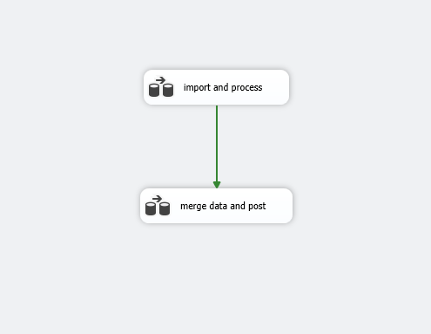

**Import and Process**

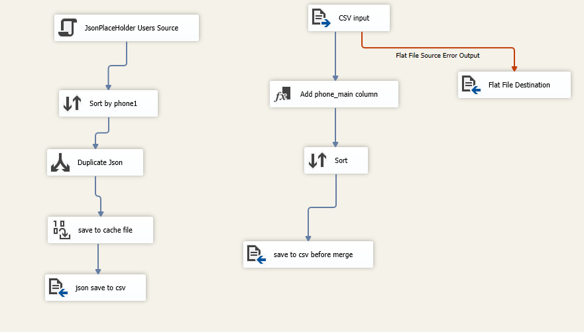

**Merge Data and Process**

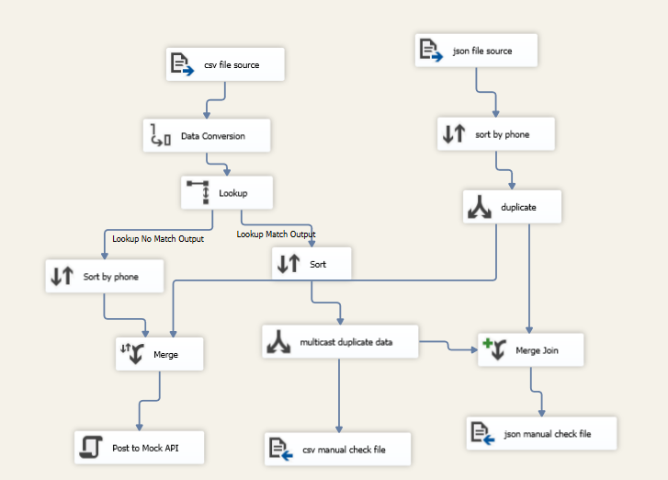

**4. Conclusion**

The cloud-based data integration solution outlined in this design document provides a comprehensive approach to integrate user data from multiple systems of Company A into Company B's system. The solution efficiently resolved data consistency, tackled error handling using SSIS data redirection mechanism. This implementation avoided cumbersome code and provided a clear picture of data processing execution.